INSTANT SKILLS IMPROVEMENT by Coach Lou DeLuca

All the parents’ eyes follow when I go on the ice for one of my Mites clinics for the first time. In my hands I carry a marker and a hand saw.
I am compelled to cut hockey sticks down to size. For years I have been overwhelmed by the misinformation and resistance to using a hockey stick short enough so it’s easy to handle. My training as a physical educator taught me early on that a properly sized implement would always enhance skill development. You may have heard it too…”the guy in the pro shop told me ‘It’s supposed to be nose-high with skates on’ ”. Many times they say their coach told them the same.
No it is not!
The rule is “chin-high”, maximum, with skates!!!
Check out these photos of NHL players with the size of their sticks:

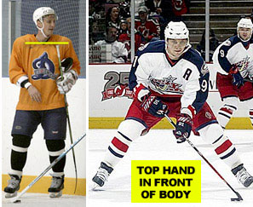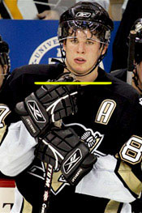
When I was a kid the game was played a lot more north-south but nowadays it involves a lot more movement and changing lanes. Players need to be able to move the stick across their body to give and receive passes in traffic. A stick just a couple of inches too long hinders this process and results in a stunting of skill development. Walking into various rinks it hurts my eyes to watch players sometimes with instructors struggling to carry a puck in drills with a stick that is obviously too long. The top hand needs to be in front of the body for proper passing and stickhandling technique….not resting against the hip.
I’ve had parents tell me (after they’ve spent way too much) that they intend their little guy to grow into the stick – this is as foolish as buying skates too big and waiting for the kid to grow into them – results would not be good. You can always get extenders for sticks for the fast growers. But those expensive sticks are just too sensitive for young hands. I also know there exists the phenomenon of ‘stick envy’ – where each kid wants to have the newest $250 composite. Please resist.
All sports play with modified equipment for younger players whether it be tennis, baseball, basketball or others. Look, it took a long time for hockey to realize that a 200 foot rink was quite an obstacle for a 6 year old. The sport of hockey is difficult enough to master skills skating on butter knives at speed with an implement and a puck and defenders. The implement of hockey stick has to be cut to size and the shaft modified for smaller hands – a cut-down adult stick won’t hack it – the shaft is too wide for small hands.
And those of you training on dry land….be sure to cut a stick even lower to compensate for lacking the height of your skates.
I’ve had kids cry because I am cutting their stick. I’ve had an irate parent accuse me of cutting the stick to get his kid to bend his knees – Hmmmm, I hadn’t even thought of that – probably wouldn’t work.
But if you want to increase your puck control instantly and put yourself in a position where your practice will really pay off….cut that stick!!
Coach Lou DeLuca played Junior B hockey in Brooklyn for Lou Vairo. He starred and later coached D3 Queens College and has been coaching and teaching at almost every Amateur level over forty years now. He has been an instructor and founder/head coach of the Dix Hills Mites hockey organization which has been playing cross-ice hockey for over 15 years. Lou lives on Long Island and Boynton Beach, FL with his figure skating professional wife, Barbara.
Photos from Howie Meeker.

